

June 2026 Fasting Report
Weight Management as Measurement and a Feedback system
A Reflective, Data-Led Personal Case Study
September 2025 – January 2026
Preface

This report describes a personal experience with fasting, and weight measurement and tracking from September 2025 to January 2026.

This report is not medical advice and is not intended to recommend fasting or any particular diet for others to follow.

Everyone’s health situation is unique, different, and anyone considering changes to their diet, practicing fasting, or undertaking a new exercise regime should always consult a qualified medical professional first.

This report is best read as a personal case study and reflection by the author.

Table of Contents

1 Introduction and Scope 3
1.1 Scope and terminology 3
1.2 Limitations of this Report 3
2 Background 4
3 Method & Constraints 5
3.1 Weekly Change Calculation 6
4 What ? 6
4.1 September 2025 7
4.2 October 2025 8
4.3 November 2025 9
4.4 December 2025 10
4.5 January 2026 11
4.6 Data Summary: September 2025 to January 2026 12
5 So What? — Analysis & Reflection 14
5.1 Overview of Key Observations 14
5.2 Measurement as a Feedback System 14
5.3 From Dieting to Adjustment: A Different Way of Thinking 15
5.4 The Role of Activity During Fasting 15
5.5 Behaviour and Biology 15
5.6 Why Fasting May Work 16
5.7 The Fridge and Freezer Metaphor 16
5.8 Fasting is a method, but not the whole story 17
6 What Next? — What was learnt ? What is significant? What are the research questions ? 18
7 Closing Reflection 19
8 Further Work 19
9 Background Reading and Influences 19

1 Introduction and Scope
The general nutritional and fasting concepts referred to in this report were influenced by the work of Patrick Holford and Dr. Alan Goldhamer [9]. Their books provided accessible explanations of blood sugar regulation, appetite, and fasting which helped inform the interpretation of the observations in this case study. This report, however, is based on personal data and reflection rather than a formal scientific study. This report describes my personal experience using fasting and gentle exercise as tools to manage my own weight. This report covers the period from September 2025 to January 2026 and is written as a reflective personal case study based on my own experience, not as a scientific study or general advice.
The purpose of this report is to reflect on this experience, identify what I have learnt during this period, and consider how these lessons might be useful in the future, both for myself and ideally for others.
This is not medical advice, and I am not directing others on what to do.
The author recognises that the quality and quantity of food intake can affect weight changes. However in this report food considerations and calorific intake are outside the scope of this report.

1.1 Scope and terminology
This report is limited in scope and focuses on physical body weight changes, fasting frequency, and general observations about my habits and routines during this period.
This report does not attempt to measure or analyse medical markers such as blood sugar or hormone levels and does not attempt to provide a scientific explanation of fasting or weight loss.
The term “fasting” is used in a simple descriptive way to describe a restricted eating pattern during this period.
The term “feasting” refers to intentional, unrestricted eating during non-fasting periods. Food is eaten to satiety without consideration to the quality or quantity of food intake.
This report focuses on what happened during this period and what was learnt from the experience, rather than trying to provide general and/or specific conclusions.
This report is based on my personal experience and measurement, informed by general reading, and is not intended to be a formal literature review. The aim is to keep the report readable and practical and to document a lived experience rather than to summarise existing technical research on the topic.

1.2 Limitations of this Report
This report is based on one person’s experience over a limited period of time.

No medical measurements such as blood tests were taken, and food intake was not measured in calories.

Body weight was used as the main measurement, which can be affected by many factors, including food intake, hydration, illness, stress, and sleep.

Exercise, sleep, stress, and life events were not controlled and varied during the period.

For these reasons, this report should be read as a personal case study and reflection rather than as medical or scientific advice.

2 Background
Weight management is often framed as a purely nutritional problem [9]. In practice, weight management is a function of quality and quantity of food intake, exercise undertaken and ones quality of life experience.
Individuals who choose to manage their weight typically do so for personal reasons linked to health, confidence, and/or quality of life.
Sustainable change rarely occurs through the force of ones will. Positive change tends to emerge from small repeatable actions. When attempting positive weight change, setbacks are common.
In my experience, reframing a setback as "What difficulties were present this time?” rather than as failure allows for learning and adjustment rather than "quitting".
In addition, small changes to one's life are preferable and more sustainable than dramatic changes; for example, a yoga pose which requires a deep stretch that feels tight today may extend further tomorrow through gradual repetition. The same applies to learning new habits: small, consistent, repeatable adjustments add up.
For weight loss to work successfully - the process of weight loss is to considered to be a feedback loop based on measurement and experience.
From a phyiscal perspective the body can use both sugar (glucose) and stored fat (converted to ketones) as fuel sources to create the energy needed to sustain daily living.
This fat conversion to ketones as an alternative fuel source to glucose can occur either through a calorie deficit with a restricted food intake or through fasting by taking in zero or minimal calories.
We all fast while sleeping and naturally move to a fat-burning state while our blood sugar is low.
Modern eating patterns, particularly the frequent consumption of refined carbohydrates and processed foods, may reduce the amount of time spent in fat-burning states.
Typically, while in a fat-burning state, blood sugar is low, insulin levels are low, and stored energy begins to be accessed by the conversion of fat to ketones; regular fasting extends the period of low blood sugar and low insulin release.
Energy balance remains fundamental to weight loss; simplistically, fewer calories in than the energy required to maintain our bodies during the day leads to a calorie deficit and a reduction in weight, namely fat loss.
For this reporting period, fasting provided a method that made calorie deficit easier to sustain. essentially there is little mental effort required to stop eating food, as apposed to traditional calorie-restrictive diets which needs one to pay constant attention to the quality and quantity of food intake.
I also note that my own weight gain has been influenced by comfort eating: using sugar, fat, and salt to produce short-term pleasure or emotional relief [9].
Measurement of my daily weight changes increased my awareness of my food intake, when not fasting and that awareness helped me to understand better how my eating habits influence my weight.

3 Method & Constraints
My weight was recorded daily in a spreadsheet and summarised using weekly averages and compared to planned weekly targets; initially a weight loss of one to two pounds per week was considered to be an achievable and sustainable target.

Morning weight serves as my first point of measurement, which I refer to as my rested weight. This is the weight we have when we wake up from sleep, and have not taken breakfast.

Weight change is reviewed on a weekly basis rather than focusing on fluctuating daily changes.

The aim was to observe the weekly average weight trend rather than focus on day-to-day fluctuations.

Fasting patterns varied week to week, typically ranging between one and four fasting days per week.

Fasting is used as a simple and practical way to reduce overall food intake and simplify daily food preparation decisions, rather than as a strict calorie-deficient-based dietary system.

In assessing a "fasting day", I have learnt from experience that better results can be obtained by sleeping through a 24-hour fast, so, for example, if I stop eating on a Monday evening at 6 pm, then my fasting day is Tuesday, and I do not break the fast typically until after 6 am on the Wednesday morning, sometimes later – as the longer I prolong the fast, the better the results are.

So a one-day fast is counted as a minimal 36-hour fast rather than a 24-hour fast and must include at least one night's sleep.

In my opinion, the most significant effects of fasting occur while we are sleeping.

Exercise during this period was generally gentle and sustained (walking, housework, hobbies), rather than intense exercise training. The focus was on maintaining regular movement over a period of one or two hours, rather than undertaking intensive exercise sessions.

December 2025 represents a pause in weight measurement. This period effectively acted as a break from active weight management. January 2026 marks a return to weight measurement and tracking.
The remainder of this report is structured using a simple reflective framework commonly used in education and psychology: What? So What? What Next?:
- "What?" - This provides a way to describe what happened.
- "So What?" - What was learnt and what was considered important, meaningful and significant
- "What Next?" - What then may be done differently in the future.

3.1 Weekly Change Calculation
Weekly change was calculated using the difference between the recorded weight at the start of the week (Monday) and the recorded weight at the end of the week (Sunday).

Weekly average weight was calculated separately using the average of daily weight measurements across the week.

Therefore, weekly weight change and change in weekly average weight are related but not identical measures, as weekly averages smooth daily fluctuations while weekly change reflects the net change across the week.

4 What ?
This report uses two weight calculations based on daily weight measurements: weekly average weight to observe the weekly trend, and weekly start-to-end weight change to measure the short-term effect of
fasting.

The average weight shows the direction of travel, both measurements act as a weekly feedback signal.

4.1 September 2025
Table 1: September 2025 Weekly Data | 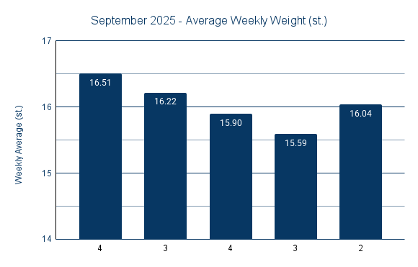  Figure 1: September 2025 - Average Weekly Weight
  Weekly Data
  Week  Commencing | Fasting  Days | Weekly  Average (st.)
  01/09/2025 | 4 | 16.51
  08/09/2025 | 3 | 16.22
  15/09/2025 | 4 | 15.90
  22/09/2025 | 3 | 15.59
  29/09/2025 | 2 | 16.04
Table 1 and Figure 1 show the weekly average weight for September 2025, along with the number of fasting days completed each week.

During September, weight decreased from 16.51 st in Week 1 to 15.59 st in Week 4, followed by an increase to 16.04 st in Week 5. Although weekly fluctuations are visible, the overall trend across the month during active fasting and measurement was downward. The number of fasting days per week ranged from 2 to 4 days, and the most significant reductions occurred during the weeks with higher fasting frequency.
Outcome: September shows strong initial weight reduction during a period of consistent fasting, with normal week-to-week variability. The final week illustrates short-term variability within an overall downward trend.

4.2 October 2025
Table 2: October 2025 Weekly Data | 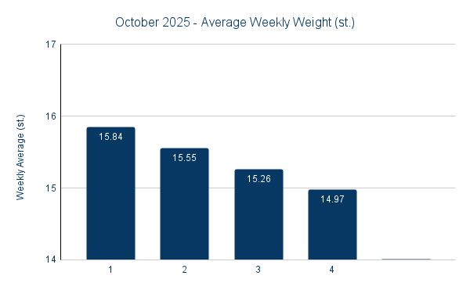  Figure 2: October 2025 - Average Weekly Weight
  Weekly Data
  Week  Commencing | Fasting  Days | Weekly  Average (st.)
  06/10/2025 | 1 | 15.84
  13/10/2025 | 2 | 15.55
  20/10/2025 | 3 | 15.26
  27/10/2025 | 4 | 14.97
Table 2 and Figure 2 show the weekly average weight for October 2025, together with the number of fasting days completed each week.
During October, weight decreased steadily from 15.84 st in Week 1 to 14.97 st in Week 4. Unlike September, the downward trend in October was more consistent, with fewer upward fluctuations between weeks. The number of fasting days increased gradually from 1 day in Week 1 to 4 days in Week 4, which coincided with a steady reduction in weekly average weight across the month.
Outcome: October confirms a sustained downward trend in weight, associated with an increasing number of fasting days per week and consistent measurement.

4.3 November 2025
Table 3: November 2025 Weekly Data | 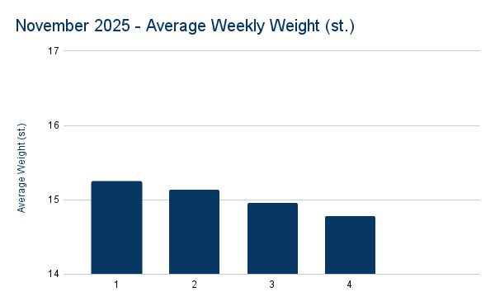  Figure 3: November 2025 - Average Weekly Weight
  Weekly Data
  Week  Commencing | Fasting  Days | Weekly Average (st.)
  03/11/2025 | 1 | 15.25
  10/11/2025 | 2 | 15.14
  17/11/2025 | 3 | 14.96
  24/11/2025 | 4 | 14.78
Table 3 and Figure 3 show the weekly average weight for November 2025, together with the number of fasting days completed each week.

During November, weight decreased from 15.25 st in Week 1 to 14.78 st in Week 4. However, the rate of weight reduction appeared slower than in September and October. Weekly reductions were smaller and more gradual compared to earlier months. The number of fasting days increased progressively from 1 day in Week 1 to 4 days in Week 4. Despite this increase in fasting frequency, the rate of weight loss did not accelerate in the same way as observed in October.

Outcome: November shows continued weight reduction, but at a slower rate than in previous months, with weight approaching approximately 15 stone by the end of the month.

4.4 December 2025

No weekly data is presented for December 2025. This period represents a break from weight measurement and fasting over the Christmas period.

Outcome: December represents a real-life interruption to fasting and measurement, providing contrast with the periods of active weight measurement, tracking and fasting.

4.5 January 2026
Table 4: January 2026 Weekly Data | 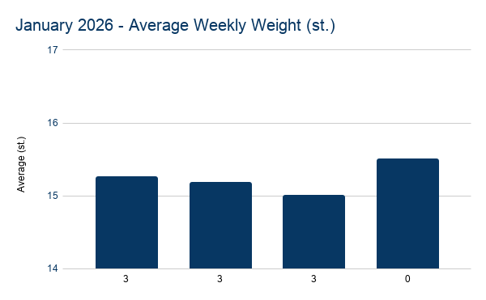  Figure 4: January 2025 - Average Weekly Weight
  Weekly Data
  Week  Commencing | Fasting  Days | Weekly Average (st.)
  05/01/2026 | 3 | 15.26
  12/01/2026 | 3 | 15.18
  19/01/2026 | 3 | 15.00
  26/01/2026 | 0 | 15.50
Table 4 and Figure 4 show the weekly average weight for January 2026, following the December measurement pause. The number of fasting days per week are shown as labels on the X-axis.

Following the December pause in measurement, weekly average weight in January began at approximately 15.26 stone. During the first three weeks, with three fasting days per week, weekly average weight gradually decreased to approximately 15.10 stone. In the final week, where no fasting days were recorded, weekly average weight increased to approximately 15.5 stone. Daily measurements during this period showed normal variability, including short periods of rapid reduction followed by temporary rebounds.

Outcome: January shows that weight increased following the December break, reduced again when regular fasting resumed, and increased again when fasting stopped in the final week. Overall, weight appeared to stabilise around approximately 15 stone during this period.

4.6 Data Summary: September 2025 to January 2026
For clarity, a consolidated weekly summary is provided showing fasting frequency, average weekly weight, and weekly change. This table is intended as a reader-facing overview. Full daily records are maintained separately in the weight-management spreadsheet.

Week | Fasting  Days | Avg  Weight (st) | Weekly  Change (st) | Weekly  Change (lbs)
01/09 | 4 | 16.51 | -0.23 | -3.2
08/09 | 3 | 16.22 | -0.29 | -4.0
15/09 | 4 | 15.90 | -0.66 | -9.2
22/09 | 3 | 15.59 | -0.41 | -5.8
29/09 | 2 | 16.04 | -0.36 | -5.0
06/10 | 1 | 15.84 | -0.41 | -5.8
13/10 | 2 | 15.55 | -0.36 | -5.0
20/10 | 3 | 15.26 | -0.09 | -1.2
27/10 | 4 | 14.97 | -0.59 | -8.3
03/11 | 1 | 15.25 | +0.53 | +7.4
10/11 | 2 | 15.14 | -0.50 | -7.0
17/11 | 3 | 14.96 | -0.57 | -8.0
24/11 | 4 | 14.78 | -0.11 | -1.5
05/01 | 3 | 15.26 | -0.41 | -5.8
12/01 | 3 | 15.18 | -0.10 | -1.4
19/01 | 3 | 15.10 | 0.5 | -7
26/01 | 0 | 15.50 | 0 | 0
Table 5: Weekly Data from September 2025 to January 2026, excluding December 2025.
Table 5 presents the weekly data from September 2025 to January 2026, with December 2025 excluded due to the planned pause in measurement.
Note: The “Average Weight” column shows the average weight for each week and is used to observe the overall trend. The “Weekly Change” column is calculated from the start-of-week weight (Monday) and end-of-week weight (Sunday). These two measures serve different purposes: the average shows the trend, while the weekly change shows the short-term effect of fasting during that specific week.

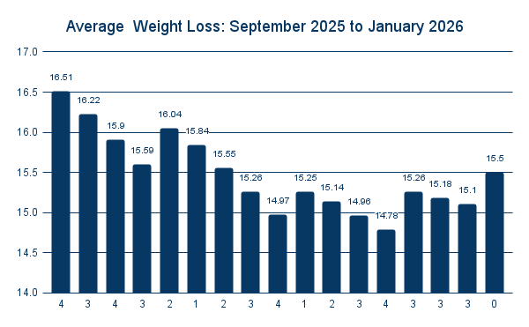
Figure 5: Weekly Data from September 2025 to January 2026, excluding December 2025.
Figure 5 provides a visual summary of the same period.

5 So What? — Analysis & Reflection

5.1 Overview of Key Observations
Several patterns stand out from the data collected between September 2025 and January 2026.

Fasting appeared effective at removing recently gained weight, particularly following periods of disruption such as holidays, illness, or breaks in routine. However, weight repeatedly returned toward approximately 15 stone, even after illness, holidays, or breaks in weight measurement. This behaviour is consistent with the body defended or stabilising around a particular body weight.

Illness and stress introduce instability into the body's hormonal system, sometimes masking fat loss without necessarily reversing it. Extended fasts are not required for meaningful weight reduction; repeated shorter fasts appeared sufficient when used consistently over time. Fasting and gentle activity appeared to act as complementary tools, while feasting supported satiety and sustainability.

Equally important, consistent measurement reduced emotional disapointment to significant daily fluctuations when feasting.

Weekly trends were more informative than daily fluctuations, and confidence grew from observing down ward trends rather than reacting to single readings.

These observations suggest that the most important factors may not have been simply fasting alone, but the combination of regular measurement, and feedback, and consistent weekly fasting and regular gentle exercise over the period of this report.

5.2 Measurement as a Feedback System
One of the most important lessons from this case study was the importance of weight measurement and feedback. Daily weight can fluctuate significantly and can be misleading if interpreted in isolation. However, when daily measurements are averaged over a week, a clear trend can be visible.

In addition, calculating weekly change from the start to the end of each week provides a simple measure of whether weekly weight is moving up or down. Using daily weight, weekly weight averages, and weekly weight changes together allowed weight to be treated not as a daily success or failure, but as a trend over time. This reduced emotional disappointment and allowed more rational behavioural adjustments to be made.

Over time, weight management began to look less like a diet and more like a feedback system. Daily weight acted as a measurement signal, weekly averages acted as a trend indicator, and fasting or food choices acted as behavioural adjustments. Illness, holidays, and life events acted as disturbances to the body's hormonal system. The goal is not perfection, but gradual adjustment based on feedback and consistent use of fasting and regular low activity exercise.

In project management, we do not expect a project to go exactly according to plan. Instead, we measure progress regularly, compare it to the plan, and make adjustments. Weight management may be similar. The weight scale provides feedback, behaviour is adjusted, and over time consistent weight loss is achievable.

5.3 From Dieting to Adjustment: A Different Way of Thinking
Traditional dieting often work like a light switch: a person is either “on a diet” or “off a diet”. When they are on the diet, they try to be very strict. When they slip, the switch goes off, and many people feel they have failed and give up completely. This all-or-nothing way of thinking makes long-term weight management very difficult because real life is not all-or-nothing.

During this case study, weight management began to feel less like a light switch and more like a dimmer switch. When weight started to drift upwards, fasting days and activity could be increased slightly. When weight returned to a comfortable range, fasting could be reduced again. The aim was not perfection, but small adjustments over time.

This “dimmer switch” way of thinking felt more sustainable and less stressful than trying to follow a strict diet continuously. It allowed for holidays, illness, and normal life, with adjustments made afterwards rather than treating disruption as failure.

This case study suggests that weight management may be more successful when treated not as a short-term diet, but as a long-term adjustment process based on regular measurement and small incremental behavioural changes.

5.4 The Role of Activity During Fasting
During November, illness resulted in a significant reduction in physical activity, including running, walking, and sustained activity before breaking a fast. In previous weeks, a routine had developed of undertaking approximately two hours of low-intensity activity before breaking a fast, which appeared to have a noticeable effect on that particular fast.

One possible explanation for the slower rate of weight loss in November is that the reduction in activity meant that glycogen stores were not being depleted to the same extent before feasting. If glycogen depletion was incomplete, the body may have relied less on fat stores during fasting periods.

This is a hypothesis rather than a scientific supported conclusion, but it suggests that fasting combined with sustained low-intensity activity may produce different results compared to fasting alone. This observation also aligns with the commonly stated principle that weight loss is influenced by both diet and activity. In this case, fasting provided the simplicity of not eating, while sustained walking and running may have increased the effectiveness of fasting periods.

5.5 Behaviour and Biology
Fasting may work for both behavioural and physical reasons.

From a behavioural perspective, fasting reduces the number of meals, reduces decision-making, and provides a clear structure. Many people find it easier to follow a simple rule such as “do not eat today” than to constantly manage portion sizes and food choices throughout the day.

From a physical perspective, fasting lowers blood sugar levels, reduces glycogen stores, and may increase the use of stored fat as a fuel source once glycogen stores are depleted.

The most important observation from this case study is that the combination of behaviour and biology appears to matter more than either one alone. However, when behaviour returned to old patterns, weight also tended to return toward its previous range. This suggests that long-term success is likely to depend on consistent behaviour rather than fasting alone.

5.6 Why Fasting May Work
One possible explanation for why fasting was effective in this case study is related to how the body stores and uses energy.

When we eat regularly, the body primarily uses glucose (sugar) from food as its main energy source. Excess glucose is stored in the liver and muscles as glycogen. As long as glycogen stores are available, the body tends to use glucose (and glycogen) as its primary fuel source.

During fasting, blood sugar levels fall and glycogen stores are gradually depleted. When glycogen stores are reduced, the body must increasingly rely on stored fat, which is converted to ketones for energy. The liver converts fat into ketones, which can be used as an alternative fuel source by the body, including the brain.

In simple terms, when eating frequently the body mainly burns sugar. When fasting for long enough, the body increasingly burns fat. This may explain why repeated fasting periods appeared to contribute to weight reduction in this case study.

However, this report does not attempt to prove a metabolic theory. A more practical observation is that fasting provides a simple method that reduced overall food intake and simplified decision-making, which may be equally important factors in weight reduction.

5.7 The Fridge and Freezer Metaphor
The body stores energy in two main ways. Glycogen is like food in a fridge - it is easy to access and used first. Body fat is like food in a freezer - it is stored for longer-term use.

If a person eats regularly, they keep refilling the fridge, so the body keeps using the food in the fridge. If a person stops eating for long enough, the fridge becomes empty and the body has to start using the food in the freezer.

Fasting is essentially a way of allowing the fridge to empty so that the freezer gets used.

5.8 Fasting is a method, but not the whole story
Many different diets can produce weight loss if followed consistently. The difficulty for most people is not knowing what diet to follow, and maintaining consistent behaviour over time.

In this case study, the most important elements appeared to be measurement and feedback. Daily weighing provided a measurement signal, weekly averages showed the trend, and weekly fasting acted as an adjustment mechanism when weight began to drift upward.

From this perspective, the scale is like a speedometer in a car. Fasting, diet, or exercise are like the pedals. The driver observes the speed and makes small adjustments to stay on course. The key difference may not be the diet itself, but the presence of regular measurement and feedback and the willingness to make small adjustments over time.

6 What Next? — What was learnt ? What is significant? What are the research questions ?
I built a personal feedback system using weight measurement and fasting, and it produced a predictable downward trend with periods of stabilisation.

What was learnt?

- Regular measurement matters.
- Weekly trends matter more than daily fluctuations.
- Short repeated fasts were easier to sustain than prolonged restriction.
- Weight can be viewed as a feedback-control problem.

What is significant?

- Weight reduced from approximately 16.5 stone to approximately 15 stone.
- The reduction was achieved without calorie counting.
- Weight returned upward when measurement and fasting stopped.
- Measurement itself appeared to influence behaviour.

Research Questions

What biological concepts need to be understood for effective weight management? In particular:

- What is blood sugar ?
- What is low blood sugar?
- What are simpler ways to deplete glycogen stores ?
- How does our weight fluctuate over a day when fasting, when eating, when feasting?
- How do the weights: rested weight, full weight and fasted weight, help to understand the maximum
potential weight loss per week given a weekly fasting cycle ?

How can these measurements be used to forecast potential fast loss and the best path of fasting ?

How can a person with no direct experience of fasting start on a path to use fasting as part of their weight loss method ?

A note on Weight Measurement

Accuracy of the weight measurement - often I would take the best weight during a day rather than specific times in the day.

As the measurements are record in a spreadsheet over time there are always possibilities of human error in data entry.

With a simple measurement and control system in place perhaps the approach can be to alter the quality and quantity of food intake with the aim of reducing sugar, fat intake and glycogen stores.

7 Closing Reflection
This document records a defined period of observation rather than a finished answer. It shows that meaningful weight change can occur without following a particular diet of food restriction.

It is possible to lose weight using fasting without focusing on the quality and quantity of food intake when eating normally or feasting.

More significantly, this case study illustrates that regular weight measurement and tracking created awareness of my food choices.

This case study suggests that long-term weight management may depend less on choosing the perfect diet and more on building a simple system of measurement, feedback, and small behavioural adjustments over time. Weight management, in this sense, is not a one-time problem solved by a diet, but an ongoing process that requires observation, interpretation, and regular adjustment.

Fasting proved to be a useful tool in this case, but it was not the whole story.

The most important factors appeared to be regular measurement, observation of average weight trend, and the ability to respond calmly to changes over time.

The key lesson was not how to lose weight quickly, but how to manage weight over time in a realistic and sustainable way.

8 Further Work
This case study has raised a number of questions that would require more structured research and are outside the scope of this reflective report.

These include:

- The concept of a defended or stabilised weight range otherwise known as one's set-point.

- The relationship between fasting duration, glycogen depletion, and fat conversion to ketones.

- The role of low-intensity activity performed in a fasted state.

- The effects of regular measurement and feedback on behaviour.

9 Background Reading and Influences

Patrick Holford — Optimum Nutrition
Patrick Holford — The Low GL Diet Bible
Alan Goldhamer & Douglas Lisle — The Pleasure Trap
Alan Goldhamer — Can Fasting Save Your Life?

